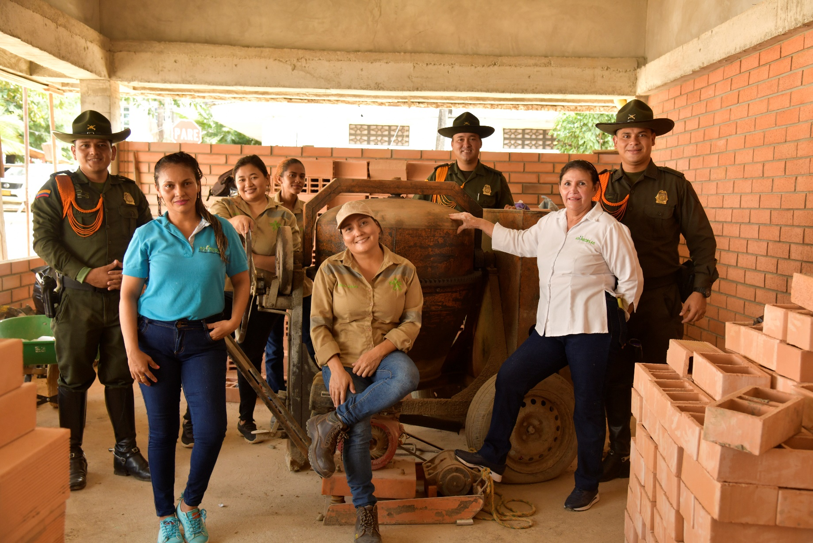

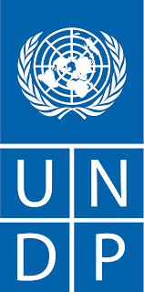
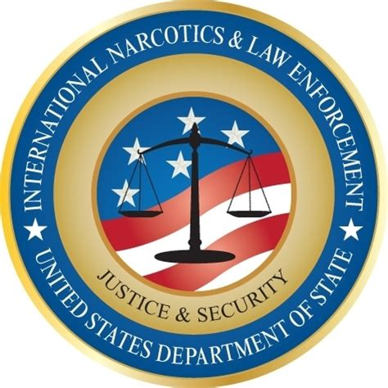

EQUITY AND PROGRESS: INFRASTRUCTURE, RURAL SECURITY, AND DEVELOPMENT PHASE II - FINAL IMPLEMENTATION REPORT

Cooperation Agreement between the Bureau of International Narcotics and Law Enforcement Affairs (INL) of the U.S. Embassy and the United Nations Development Programme (UNDP) in Colombia

Implementation Period: March 31, 2021, to October 31, 2024

November 2024

Table of Contents

Project Overview 3
Project Overview 4
Geographic Location 4
Targeted Production Lines 5
Types of Delivered Infrastructure 5
Organizations and Total Beneficiaries 6
Methodological Transfer and Capacity Building for the Police 6
Capacity Building for the Colombian National Police 7
Images of Strengthening Activities with the Police 9
Strengthening Farmer Organizations 11
Strengthening Organizations of Small Rural Producers 12
Construction of Community Infrastructure 16
Construction of Community Infrastructure 17
Organizational and Community Strengthening 18
Improved Perception and Trust in Rural Police 22
Baseline and Exit Line Analysis: Community perception regarding DICAR, support for small producer organizations, social capital and trust 23
Lessons Learned 27
Lessons Learned 28

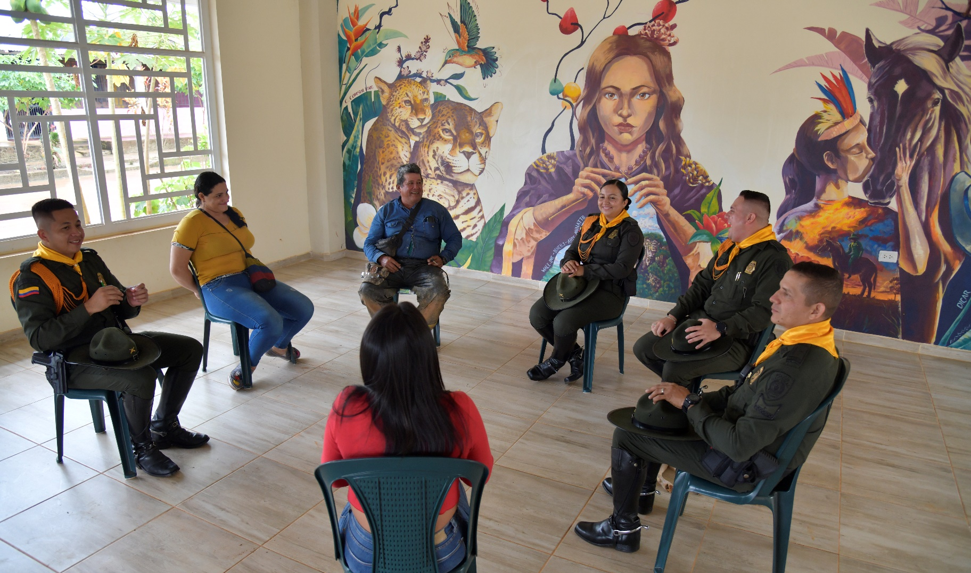

Project Overview

Project Overview
Purpose:
To provide the Colombian National Police/Directorate of Carabineros and Environmental Protection with the tools and capacity to implement rural development and community infrastructure initiatives intended to build public confidence and foster lawful livelihoods. These endeavors align with the mission of the Bureau of International Narcotics and Law Enforcement (INL) of the U.S. Embassy to combat illicit crops and drug trafficking, expand state presence, enhance citizen security, and promote lawful economic development.
Objective 1: To strengthen DICAR's capacity to effectively carry out activities in rural areas that engender trust amongst local communities to promote lawful economic opportunities and sustainable rural development.
Objective 2: To support DICAR in implementing plans aimed at strengthening farmers' organizations, fostering livelihoods within the framework of the law.
Objective 3: To create innovative opportunities to collaborate with DICAR's infrastructure managers on joint infrastructure projects aimed at enhancing territorial development and fostering close cooperation with the community.
Objective 4: To implement a comprehensive strategy for monitoring, follow-up, evaluation, and dissemination.

Geographic Location
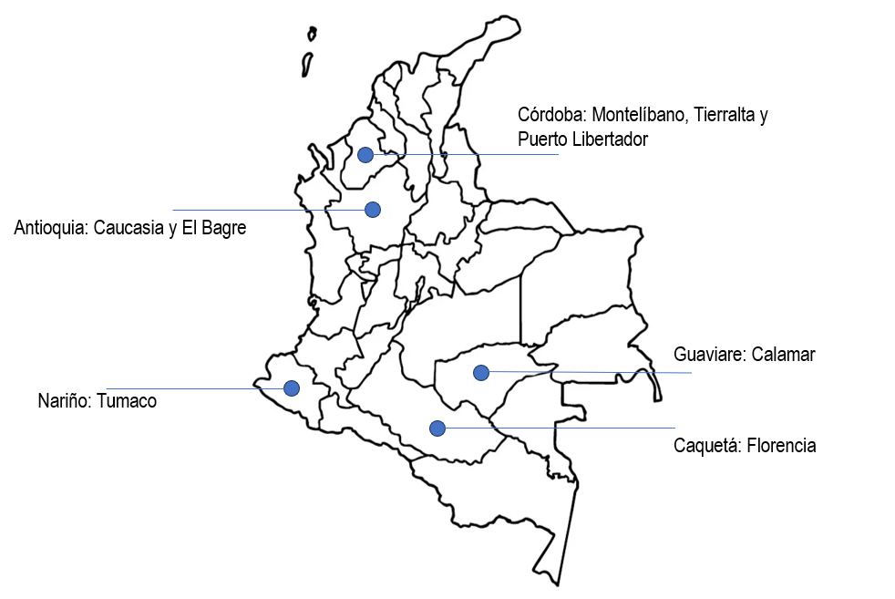

Targeted Production Lines
During the project implementation, various production lines based on rural economy models were strengthened, consolidating them as viable and sustainable alternatives for income generation within the framework of the law. The promoted productive activities included cacao and plantain cultivation, fish farming, and honey production through beekeeping.

The Directorate of Carabineros and Environmental Protection played a crucial role in boosting these economies, supporting the adoption of sustainable practices and ensuring compliance with various regulations. These initiatives not only improved the economic conditions of participating communities but also encouraged the responsible use of natural resources, promoting agricultural and environmental management practices with a positive long-term impact on the intervened regions.

Types of Delivered Infrastructure
During the second phase of implementation, nine (9) community works were delivered, including family and sports parks, soccer fields and multi-sport courts, community coexistence centers, cultural centers, women’s shelters, gyms, and functional classrooms. The construction of these spaces followed the “Infrastructure for Development” methodology based on co-design and co-construction models with the communities. Additionally, support was provided through an organizational and community strengthening pathway aimed at building capacities for communities to manage their own development. This included formalizing labor conditions, developing leadership, coordination, administrative, and financial skills, and promoting sustainability, gender equity, and environmental resilience actions.

Organizations and Total Beneficiaries
The Colombian National Police supported a total of 30 community organizations, of which 21 are formally established rural producer collectives dedicated to the lawful production of cacao, plantains, honey, and fish farming. These organizations, committed to sustainable development and the economic strengthening of their communities, partnered with the police institution to drive progress in their territories.

Meanwhile, the remaining nine organizations are part of the civil society and are primarily composed of Community Action Boards, Community Associations, and Cooperatives. These entities focused on implementing community infrastructure projects, working in coordination with the National Police. Notably, the Female Rural Operations Squad (EFEOR in Spanish) played a key role in this process, leading and promoting collaborative efforts to construct facilities that benefit rural communities, strengthen social fabric, and promote legality in the areas where they operate. This collaborative effort not only reinforces local development but also builds trust between communities and security forces, consolidating an environment for peace and prosperity.

In addition, the second phase of the project generated 158 formal jobs for 69 women and 89 men. Through infrastructure projects, this impacted the lives of 540 families, whose livelihoods relied on rural economy models supported by the intervention, which strengthened productive, commercial, and associative capacities for various lawful crops.

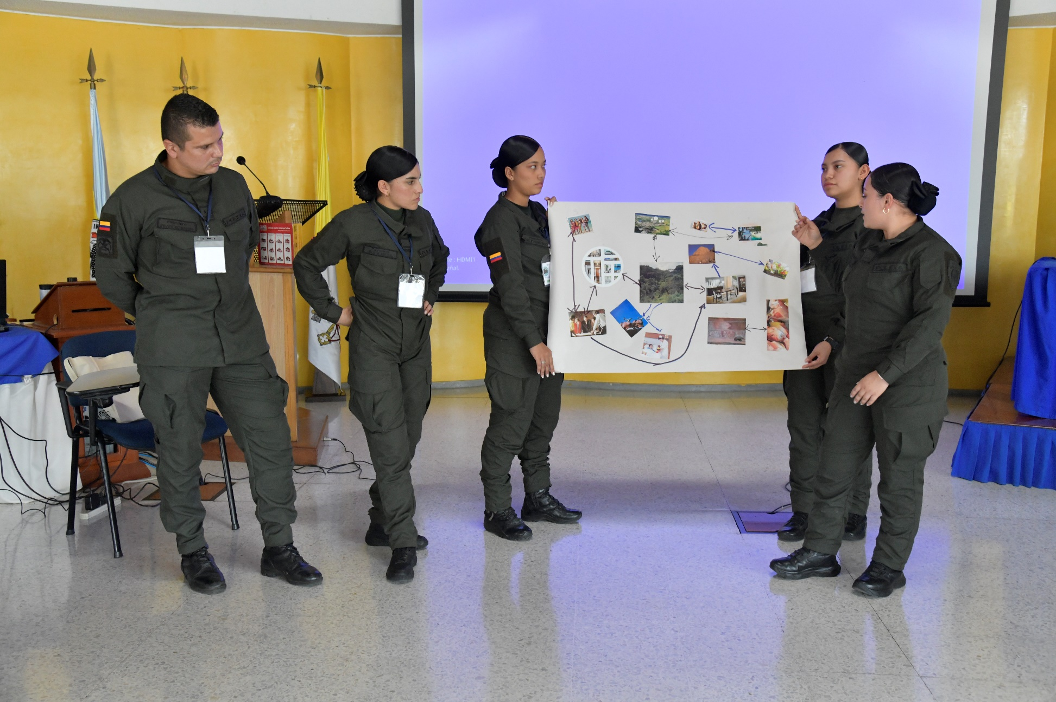

Methodological Transfer and Capacity

Building for the Police

Capacity Building for the Colombian National Police
A core pillar of this project phase was the strengthening of law enforcement capacities, with a focus on the Directorate of Carabineros and Environmental Protection. The primary objective was to provide tools and skills to members of the Colombian National Police to improve their interaction and engagement with communities in regions affected by armed conflict, where deep fractures have been generated, weakening and limiting relationships between public forces and civil society. To address this issue, the project prioritized strategic and coordinated collaboration with various key areas of the Colombian National Police. This collaboration included not only officers from police stations and substations but also infrastructure managers (partially) and the Female Rural Operations Squad, whose role is critical in building trust and fostering stronger community integration.
Within this context, the project developed a series of spaces for methodological transfer, promoting knowledge exchange and capacity strengthening throughout its implementation. The following is a detailed compilation of these training spaces and the key achievements, reflecting the positive impact of this joint effort on reconstructing social fabric and improving relations between public forces and local communities. The summary includes the capacity-building sessions conducted with the Colombian National Police, where approximately 142 officers participated in specialized workshops or took part in work sessions with beneficiaries from civil society organizations.
Table 1. Strengthening the Directorate of Carabineros/Colombian National Police

Event | Location and Date | Session Summary
First Induction Session with the Carabineros and EFEOR Group | August 2021 | During the First Induction Session for the Carabineros and the Female Rural Operations Squad (EFEOR), participants received training in community development management and women’s empowerment. Key takeaways included understanding effective strategies to promote female participation and leadership in rural communities, as well as the importance of fostering gender equity in both policing and community settings. The session emphasized the need to establish support and collaboration networks among women, both within the squad and the community, to advance projects that benefit the integral and sustainable development of rural areas. Carabineros acquired skills to identify and address the specific needs of women in their communities, promoting an environment of respect, security, and empowerment. Additionally, they were provided with tools for community engagement and building trust with local populations.
Second Induction Session with the Female Rural Operations Squad | January 2022 | During this training session, policewomen were trained on the process of addressing gender-based violence. The main lessons learned included identifying and understanding the various forms of gender-based violence and their impact on victims. Participants were trained in specific protocols and procedures for assisting and supporting victims from the first contact, ensuring respectful and empathetic treatment. The importance of inter-institutional coordination was highlighted to provide comprehensive support, including medical, psychological, and legal services. Additionally, the session underscored the need for sensitization and continuing training for all police members to ensure effective, quality care and to foster a safe, supportive environment for women affected by gender-based violence.
National Induction Session in Bogotá | April 2022 | During this training session for the Colombian National Police on working with rural communities, participants gained valuable insights focused on fostering equity and progress. The importance of building trust-based, collaborative relationships with community leaders was emphasized, along with understanding the specific dynamics and needs of rural populations. Officers were trained in effective communication techniques and the implementation of participatory projects that actively involve local communities. Strategies for promoting gender equity and empowering women in these communities were also addressed. The training highlighted the significance of promoting sustainable development through initiatives that respect the environment and value local resources. In summary, police officers enhanced their skills to work inclusively and respectfully, driving well-being and progress in Colombia's rural areas.
Training with the National Training Service (SENA) in Tumaco | March 2023 | Key lessons focused on the importance of environmental conservation as a foundation for sustainable development. Participants learned how to integrate ecological practices into their tourism and entrepreneurial projects, emphasizing the value of local natural and cultural resources. The session stressed creating initiatives that not only generate income but also preserve and promote regional biodiversity and traditions. The training encouraged collaboration between the police and the community to establish a safe and attractive environment for tourism, enhancing Tumaco’s image as a responsible destination. Overall, capacities were strengthened to develop innovative projects that boost local economic growth while respecting and protecting the area’s natural and cultural heritage.
Bootcamp with Universidad de La Salle | March 2024 | The course had a significant impact on nearly 30 female officers from the Female Rural Operations Squad. They received training in i) Formulation and management of social projects in rural areas; ii) Oral expression techniques, public speaking, and assertiveness; and iii) Development of community action plans with an environmental focus. Key recommendations arising from this course include: i) Continuing and expanding training activities with a focus on environmental sustainability and rural development; ii) Promoting the implementation of the developed community environmental action plans and encouraging the integration of circular economy practices into rural public policies. See Annex 4 for the full report.
Participation in the Organizational and Community Strengthening Pathway and Environmental Strategy | Permanent during project implementation | The training emphasized developing new competencies and soft skills, including transformational leadership, peaceful conflict resolution, third-generation human rights, assertive communication, gender sensitivity, community agreements for project ownership, water cycle, recycling, and waste management, as well as environmental compensation activities. The methodological transfer incorporated the need to adapt training content to the specific realities of both the Police and the involved communities, ensuring its relevance, understanding, and applicability. Additionally, the program highlighted the importance of engaging community actors and local organizations to strengthen trust and collaboration. Continuous feedback and periodic evaluation emerged as critical elements for refining and enhancing the program, ensuring that the acquired knowledge translates into sustainable practices and tangible benefits for all stakeholders.

Images of Strengthening Activities with the Police

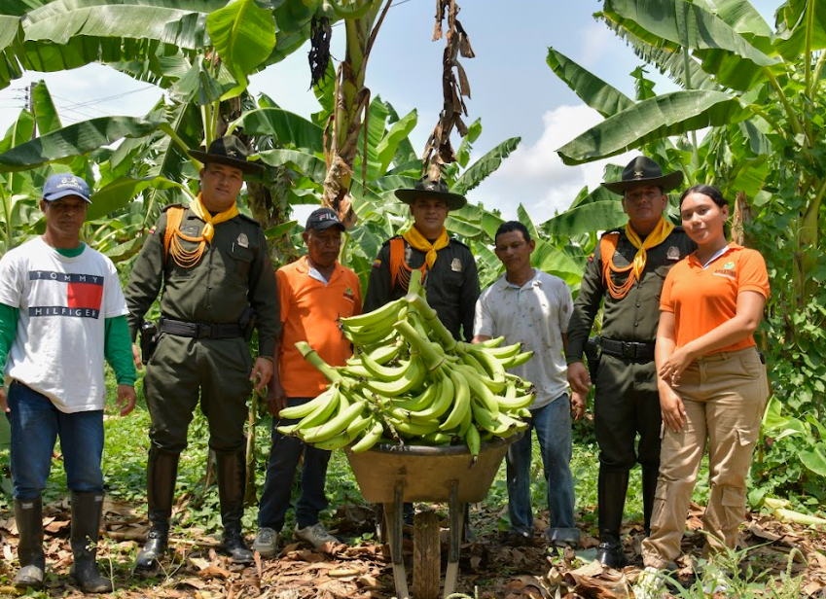

Strengthening Farmer Organizations

Characterization of Territorial Productive Profiles
During this phase of implementation, the Police and the community jointly carried out the economic and productive characterization of prioritized crops, including cacao, fish farming, plantain, and beekeeping. This was aimed at generating relevant information for decision-making by producers and local development organizations. To achieve this, the project defined a clear intervention route, focused on managing the characterization directly within communities and their territories.
This process involved data collection, capture, validation, and interpretation, ensuring a participatory and context-sensitive approach.
As part of the process, calls for proposals were made through previously selected organizations, aimed at engaging qualified professionals from the intervention areas to develop productive profiles. These professionals developed six territorial productive profiles, which have been presented as infographics and are available in Annex 1.
In addition to characterizing the productive profiles, a detailed analysis was conducted comparing return on investment with illicit economies. This analysis provides valuable insights for project beneficiaries and institutions in the regions, facilitating the design of alternative development models to eliminate illicit crops and promote long-term sustainable economies. This evidence-based, collaborative approach represents a significant step toward creating viable alternatives that support the integral development of communities in the intervention areas.
Image 1. Infographics detailing productive profiles developed by community experts in project regions.
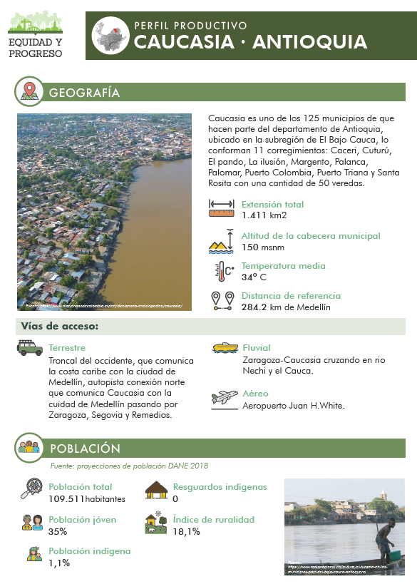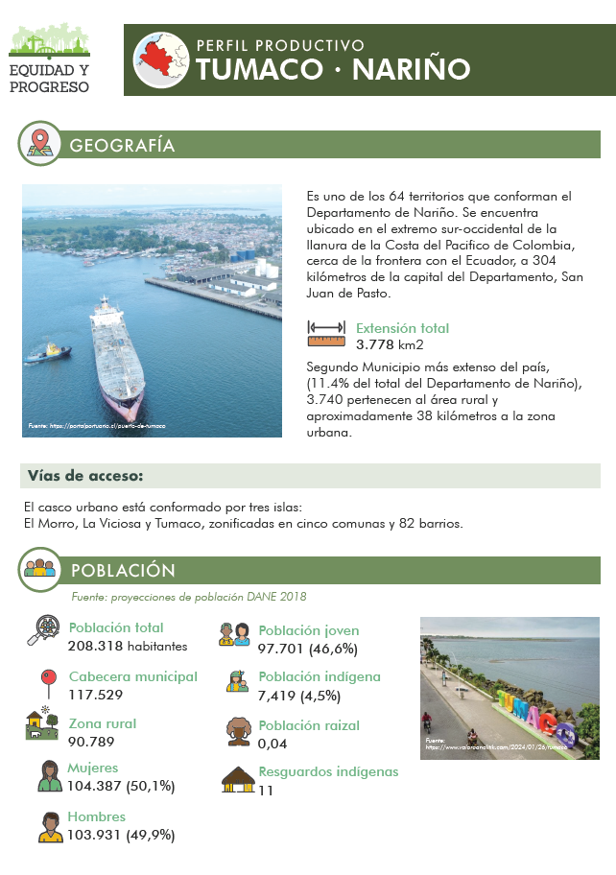

Strengthening Organizations of Small Rural Producers
Under the component of strengthening organizations of small rural producers, 19 agreements were signed to support 21 organizations of small producers, benefiting 545 families and involving approximately 1,855 rural inhabitants engaged in cacao, plantain, fish farming, and beekeeping production. These production lines, based on rural economic models, have been established as alternatives for generating prosperity and contributing to poverty reduction within the framework of the law in the targeted territories.
The agreements with beneficiary organizations were developed and signed during the third quarter of 2022, with the aim of strengthening productive units. This enabled participating families to learn and practice technical, commercial, and organizational skills to generate sufficient and sustainable income, thereby improving their living conditions. All this was facilitated through DICAR's ongoing support.
The process for structuring the agreements was based on the UNDP's Rural Economic Development methodology. Once organizations were selected, and with DICAR's participation, Dream Maps, Development Plans, and Investment Plans were created for each participating organization. This process allowed for a clear understanding of each organization's goals, projections, and interests within the framework of their associative work, thus enabling the design of a plan to strengthen their selected main production line.
Below are examples of typical activities included in the agreements:
- Strengthening productive units: Productive infrastructure, expansion and improvement of production areas, plant materials, supplies, equipment, and tools.
- Strengthening organizational capacities: Associative infrastructure, supplies, equipment, and organizational branding.
- Strengthening commercialization processes: Infrastructure for marketing or adding value, and facilitation of participation in negotiation spaces.
- Technical assistance across the production process.
On average, more than 85% of the resources invested in each agreement were allocated directly to investments in productive infrastructure, supplies, equipment, and tools for managing units, harvests, and post-harvest processes.
The total number of beneficiaries under the component for strengthening small rural producers amounted to 508 families. The table below presents the relationship between the productive assets delivered and the infrastructure constructed.
Table 2. Strengthening Productive Organizations

Dept. | Municipality | Organization | Productive Assets and Infrastructure
Antioquia | El Bagre | ASOCIACIÓN GENTE Y BOSQUES (BEEKEEPING) | Workshop for the fabrication of beekeeping tools (279 m²)  Collection center and administrative area with sanitary facilities (248 m²)  Creation of 3 forest nurseries (6,665 forest and fruit tree seeds, 1,600 seedlings),  Workshop equipment (carpentry tools and machinery)  Post-harvest equipment (tools and containers for honey handling )  Administrative area equipment (computer, printer, chairs)  Uniforms and promotional materials with the organization's branding
Antioquia | El Bagre | ASAGROAMBIENTALES  (FISH FARMING) | Administrative area construction (15 m²)  Post-harvest zone adaptation and equipping (≈59 m²)  Well installation and septic system  Adaptation of 7 ponds (60 hours of machine work)  Unit strengthening (fingerlings, feed concentrate)  Provision of a tool kit  Post-harvest equipment (for handling, freezing)  Office equipment (furniture, chairs, tables)  Diversification of productive units (broiler chickens)  Uniforms with organization branding  Cargo motorcycle (400kg capacity)
Antioquia | Caucasia | CORCOVER  (BEEKEEPING) | Construction of a warehouse and processing area (cold room)  Unit strengthening: 175 hives with bee nuclei and feed supplements  Harvest and post-harvest equipment (for honey extraction, handling, and processing)  30 beekeeping suits and kits (knives, gloves, containers)  Office equipment (computer, furniture, chairs, tables)  Uniforms with organization branding  Cargo motorcycle (400kg capacity)
Antioquia | Caucasia | COPESARPA  (FISH FARMING) | Construction of an administrative office  Construction of a post-harvest space and a larva production lab  Security hut  3 adapted ponds 16,800 m² with a production capacity for 70,000 cachamas or tilapias, broodstock, and feed concentrate  A 9-meter fiberglass canoe  A 2-stroke motor  Productive unit and harvest equipment (tools, engines, pumps, lighting systems)  Provision of equipment for laboratory , post-harvest, and administrative areas (laboratory tools, freezing and fish-handling equipment, computers, office furniture, chairs, and desks)  Uniforms with organization branding
Antioquia | Caucasia | ASGRICAUCA  (FISH FARMING) | Construction of administrative headquarters (48 m²) with sanitary facilities, a post-harvest area of 36 m², and a warehouse  Expansion of ponds and improvement of 18 production units, broodstock, and feed concentrated.  Provision for the post-harvest and administrative areas (freezing and fish-handling equipment, computers, office furniture, chairs, and desks)  Uniforms with organization branding  Cargo motorcycle (400kg capacity)
Córdoba | Tierralta | ASOCIACION DEL CAMPO PROALSI  (PLANTAIN) | Improvement of administrative headquarters, meeting area, and kitchen  Construction of an ecological composting hub (160 m²)  Equipment for the composting hub (tools and a shredder)  Strengthening of productive units (pumping equipment, 39 irrigation systems, fertilizers, and crop protection supplies)  Uniforms and promotional materials with organizational branding  Post-harvest equipment (washing tanks, knives, and baskets)  Cargo motorcycle (400kg capacity)
Córdoba | Tierralta | ASPANU  (PLANTAIN) | Construction of administrative headquarters: office, meeting room, sanitary facilities, and warehouse (64 m²)  Unit strengthening (supplies kit, spraying equipment for sigatoka control, adaptation of 20 irrigation systems, and pumping equipment)  Post-harvest tools (baskets, knives, and washing tanks)  Office equipment (computer, printer, air conditioner, desk)  Uniforms and promotional materials with organizational branding  Cargo motorcycle (400kg capacity)
Córdoba | Tierralta | APRASINU  (PLANTAIN) | Unit strengthening (spraying equipment for sigatoka control, adaptation of 20 irrigation systems, and pumping equipment)  Provision of a tool kit  Office equipment (computer, printer, desk)  Uniforms and promotional materials with organizational branding
Córdoba | Tierralta | ASOAPESAN  (FISH FARMING) | Construction of office and sanitary facilities with foundations in solid material and a wooden structure (30 m²)  Unit strengthening (improvement of 8 floating cages, electrical systems, fingerlings, and feed concentrate)  Post-harvest equipment (fish-handling tools and freezing equipment)  Uniforms with organization branding
Córdoba | Tierralta | ASOPECAS  (FISH FARMING) | Unit strengthening (improvement of 3 earthen ponds and 3 floating cages, aeration systems, fingerlings, and feed concentrate)  Post-harvest equipment (fish-handling tools and freezing equipment)  Uniforms with organization branding
Córdoba | Tierralta | CRIADORES DE PECES  (FISH FARMING) | Unit strengthening (improvement of 3 earthen ponds and 3 floating cages, aeration systems, fingerlings, and feed concentrate)  Post-harvest equipment (fish-handling tools and freezing equipment)  Uniforms with organization branding
Córdoba | Tierralta | ASOAGROMIEL  (BEEKEEPING) | Construction of a beekeeping logistics center (collection center, office, meeting room, and sanitary facilities (80 m²)  Workshop for hive repair and manufacturing  Unit strengthening (four collecting units with hives and supers, honey collection tools and transport to the collection center, and propolis collection equipment)  Apiculture center equipment (wet, processing, storage, and packaging areas)  Office equipment (computer, printer, desk, and chair)  Uniforms and promotional materials with the organization's branding  Two temporary nurseries, with a capacity for 2,000 forest honey plants
Córdoba | Puerto Libertador | ASOCOVICAMPA  (FISH FARMING) | Construction of an administrative office (30 m2)  Construction of a storage warehouse (17.6 m²)  Construction of a shared gutting area (64 m²)  Unit strengthening (pond adaptation, motor pump, feed and tools bank, aeration systems, and fingerlings)  Office equipment (computer, printer, desk, and chairs)  Post-harvest equipment (fish-handling tools and freezing equipment)  Uniforms and promotional materials with the organization's branding
Córdoba | Puerto Libertador | ASOAGRO  (FISH FARMING) | Construction of a warehouse (17.6 m²)  Construction of a shared gutting area (24 m²)  Unit strengthening (pond adaptation, motor pump, power plant, feed and tools bank, aeration systems, and fingerlings)  Office equipment (computer, printer, desk, and chairs)  Post-harvest equipment (fish-handling tools and freezing equipment)  Uniforms and promotional materials with the organization's branding
Córdoba | Puerto Libertador | AFAPUL  (CACAO) | Improvement of administrative headquarters and meeting room  Installation of 3 cacao drying modules  Unit strengthening (supplies bank, tool kit, pruning kits, grafts, and renewal of plant material)  Post-harvest tools (drying modules and fermentation boxes)  Office equipment (computer, printer, desk, and chairs)  Uniforms and promotional materials with the organization's branding  Cargo motorcycle (400kg capacity)
Córdoba | Montelíbano | ASOCIACIÓN UNIDAS CONSTRUYENDO FUTURO  (PLANTAIN) | Construction of an administrative office (16 m2)  Collection center (56.2 m²)  Unit strengthening (supplies bank, tool kit, irrigation systems, and plant material)  Post-harvest tools (washing tanks and baskets)  Office equipment (computer, printer, tv, desk, and chairs)  Uniforms with organization branding  Canoe  with a two-stroke motor
Córdoba | Montelíbano | PAAS  (FISH FARMING) | Construction of an administrative headquarters for the organization (16 m²)  Construction of a warehouse (18 m²)  Unit strengthening (aeration equipment, concentrated feed bank, and hermetic storage tanks)  Post-harvest tools (baskets and plastic tanks)  Office equipment (computer, printer, tv, and chairs)  Uniforms with organization branding
Nariño | Tumaco | ASUP  (FISH FARMING) | Expansion and modernization of the fish farming productive unit (provision of 7 geomembrane ponds with equipment for modernization) Improvement and expansion of 3 earthen ponds and the access road to the productive unit  Infrastructure improvement for gutting processes (24 m²)  Unit strengthening (fishing tools, fingerlings, concentrated feed, power plant, protective mesh)  Post-harvest tools (gutting table)  Office supplies (stationery, printer)
Nariño | Tumaco | ASOPROCUARIOS  (FISH FARMING) | Construction of a shed for installing the power plant and storing tools  Unit strengthening (fishing tools, fingerlings, concentrated feed, power plant, expansion and improvement of 2 collective earthen ponds, protective mesh, quality measurement kits)  Post-harvest tools (gutting table)
Nariño | Tumaco | ASAETA  (FISH FARMING) | Improvement of 4 collective fish farming ponds (4,200 m²)  Construction of 11 collective fish farming ponds (5,500 m²)  Construction of 4 nursery ponds (675 m²)  Unit strengthening (fishing tools, fingerlings, concentrated feed, power plant)  Expansion and improvement of 3 collective geomembrane ponds with aeration systems, protective mesh, quality measurement kits  Post-harvest equipment (freezer)  Office provision (stationery, computer, printer)
Nariño | Tumaco | AGROUNIÓN  (FISH FARMING) | Expansion and modernization of the fish farming productive unit (provision of 3 geomembrane ponds with equipment for modernization)  Unit strengthening (fishing tools, fingerlings, concentrated feed, power plant)  Expansion and improvement of 4 collective earthen ponds, construction of 15 ponds, protective mesh  Quality parameter measurement kits  Post-harvest equipment (freezer)  Office provision (stationery, computer, printer, and office furniture)  Provision and strengthening of the agricultural supply store

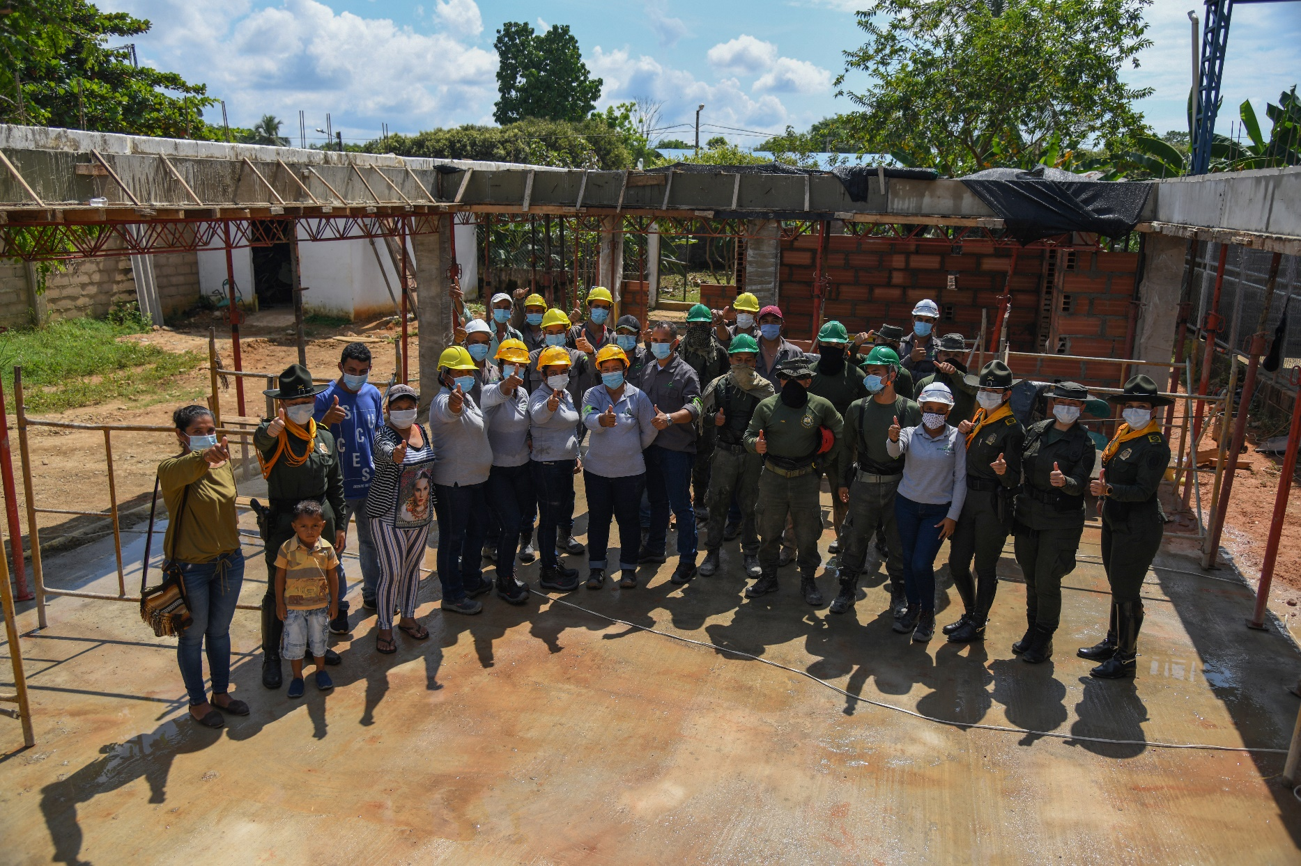
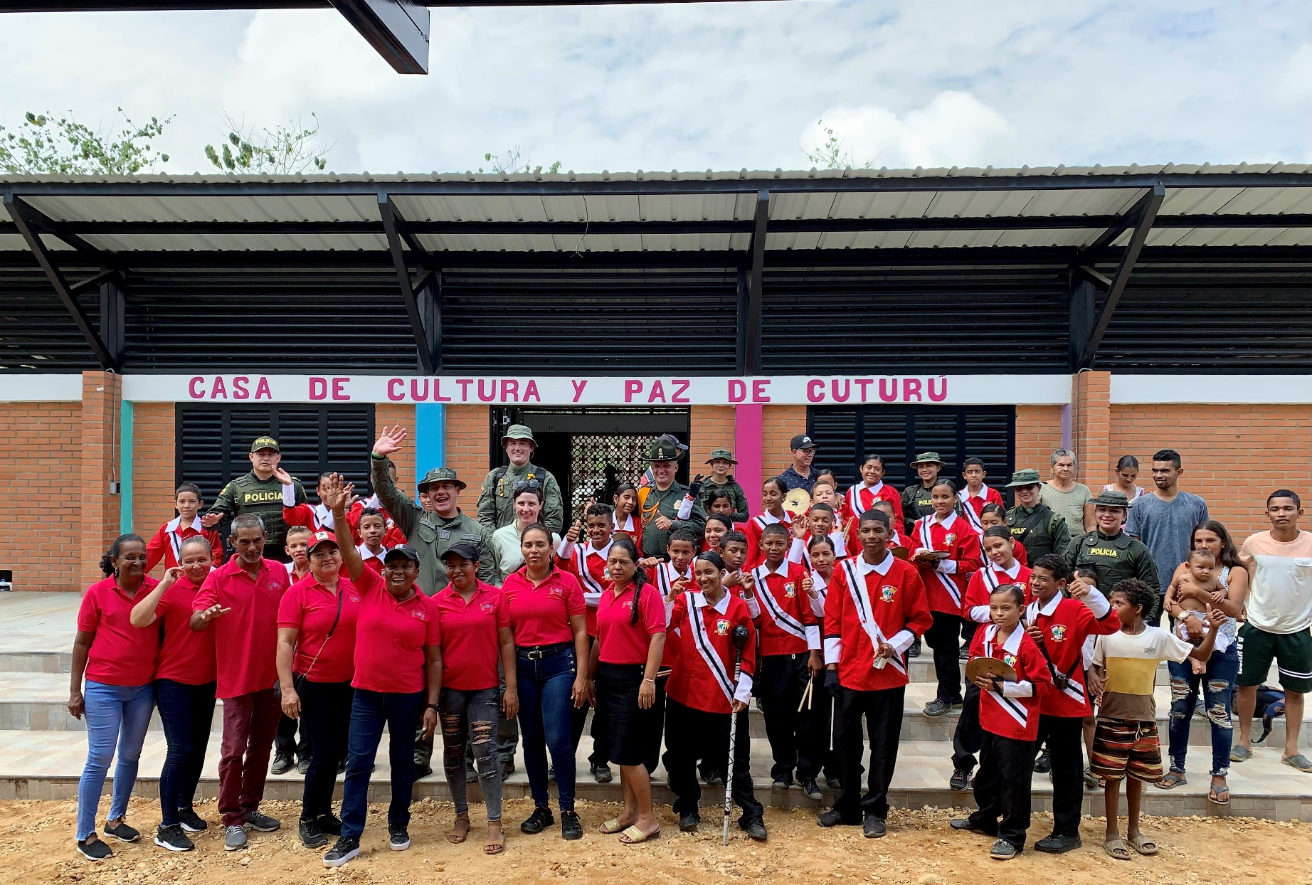

Construction of Community

Infrastructure

Construction of Community Infrastructure
Since 2018, the Equity and Progress project has worked in coordination with the National Police to build community infrastructure projects. In this process, civil society organizations have played a fundamental role as main implementers, allowing them to become managers of their own development and create interaction spaces with law enforcement. This has facilitated the creation of stronger bonds and contributed to reconciling a historically fragmented relationship due to armed conflict and illegal economies.
The UNDP’s infrastructure-for-development model is based on several principles that have guided community and police participation in project selection, architecture co-design, project development, and the use, ownership, and sustainability of infrastructures. In this process, the Female Rural Operations Squad (EFEOR) has played a key role, representing a disruptive model in the territories. The community perceives that the police can develop spaces of fraternity that promote peaceful coexistence and sustainable development. Unlike the first implementation phase, community infrastructure managers did not participate this time—a decision made by INL and the National Police. Although this caused some initial difficulties, they were overcome thanks to EFEOR’s intervention.
It is essential to highlight that the continuity of these collaborative efforts between the community and the National Police is crucial for ensuring the success and sustainability of the initiatives. Building mutual trust improves security and coexistence in the territories and contributes to long-term social stability. Keeping these communication and cooperation channels open allows communities to solidify their role as protagonists of their development, while law enforcement strengthens its legitimacy as a key ally in promoting peace and sustainable development. Persisting in this approach will be decisive in transforming and reconciling historically conflictive relationships.

The project also affirms the importance of women’s active participation in project development, strengthening gender equity in highly male-dominated fields like construction. Additionally, the projects included an environmental strategy to offset the carbon footprint naturally generated by infrastructure works.

Below are the works delivered to the community:

Table 3. Infrastructure Works Delivered by the Project

Department | Municipality | Area | Type of Work | Implementing Community Organization | Progress | Inaugurated by Police
Antioquia | Caucasia | Cuturú | Culture and Peace House | Visión de Futura association-Cuturú | 100% | Inaugurated
Nariño | Tumaco | La Guayacana | Sports and Recreational Center  “La Guayacana” | Mira Farmer Association- AGROMIRA | 100% | Inaugurated
Caquetá | Belén de los Andaquíes | Caja Agraria neighborhood | Restoration of Caja Agraria field | Ciudad Modelo Community Action Board | 100% | Inaugurated
Córdoba | Montelíbano | Tierradentro | Community Coexistence Center | ASOCOMUNAL Rural of Alto San Jorge | 100% | Inaugurated
Antioquia | El Bagre | Puerto Claver | Soccer field | COOPROC LTDA Cooperative | 100% | Inaugurated
Caquetá | Belén de los Andaquíes | Ciudad Modelo neighborhood | “Ciudad Modelo” family park | Ciudad Modelo Community Action Board | 100% | Inaugurated
Córdoba | Tierralta | 9 de agosto neighborhood | “9 de Agosto” sports park | Tierralta Community Environmental Managers Association | 100% | Inaugurated
Córdoba | Puerto Libertador | Centro neighborhood | Puerto Libertador coexistence center | Puerto Libertador Environmental Recyclers Association | 100% | Inaugurated
Guaviare | Calamar | La Independencia neighborhood | Women’s and Coexistence Center | Calamar Community Action Board Association | 100% | Inaugurated

Organizational and Community Strengthening
The Organizational and Community Strengthening Route is the methodology implemented by the project during the construction of community infrastructure. Its primary goal is to develop skills, competencies, and capabilities within civil society organizations, enabling them to gain experience in executing small-scale infrastructure projects through resource management under a grant-based model.
The National Police plays an active role throughout the process, from selecting organizations to participating in community workshops for co-design, attending technical work committees, and supporting organizational board meetings. Additionally, they facilitate soft skills workshops covering teamwork, assertive communication, leadership, conflict resolution, strategic planning, business model definition, and project and community initiative management. These activities became catalysts for community engagement, fostering environments that promote peaceful coexistence and strengthening cohesion in these territories.
The participation of the Female Rural Operations Squad (EFEOR) in the Organizational and Community Strengthening Route has been instrumental in the success of this project by introducing a gender perspective into the community-building process. This squad has gone beyond its security functions, actively strengthening women’s leadership within civil society organizations. Their presence enhanced the effectiveness of soft skills workshops, particularly in leadership and assertive communication. Moreover, they served as role models for women in the communities, inspiring them to actively promote social cohesion and peaceful coexistence in their territories.
EFEOR also played a vital role in environmental compensation activities conducted with the communities. Their community-focused approach and commitment to environmental protection have been key in engaging residents in reforestation, water body cleanup, and environmental education activities. These efforts not only showcased EFEOR's operational capacity in rural contexts but also fostered greater environmental awareness among community members, reinforcing the link between security, sustainability, and community development. Preserving and strengthening the intervention

model implemented in the Organizational and Community Strengthening Route, with EFEOR's prominent participation, is essential for consolidating the achievements made thus far. This approach has proven effective not only in developing community infrastructure but also in building trust and cooperation between the Police and civil society organizations. Actively involving women in leadership roles and working collaboratively with the community has fostered an environment that supports crime prevention through a comprehensive approach. Continuing with this model will strengthen social fabric, emphasizing mutual respect and peaceful coexistence.
In a third implementation phase, it will be crucial to deepen social and situational crime prevention efforts, leveraging the trust and close relationships built between the Police and communities. By expanding and strengthening soft skills programs alongside situational prevention strategies, such as improving urban and rural environments, police interventions can become more proactive and effective. EFEOR's participation in these efforts is vital to solidify their role as a bridge between the Police and the community, enhancing dialogue, prevention, and security while fostering a more seamless and effective interaction that promotes peaceful coexistence across territories.
It is important to highlight that through this component of organizational and community strengthening, members of DICAR and EFEOR were able to acquire knowledge and tools in four main thematic areas: 1. Leadership and Soft Skills: Topics included teamwork, leadership, conflict resolution, emotional management, and assertive communication. 2. Human Rights and Gender Approach: This was addressed through a portfolio on third-generation human rights, GBV awareness, reporting and support routes, roles and stereotypes, emerging masculinities, and care economy. 3. Environmental compensation including waste management and disposal, water cycle, and resilience to climate change. 4. Community agreements focused on the use, appropriation, maintenance, and sustainability of the constructed facilities. These topics were developed by EFEOR and DICAR teams on-site and were directed at grassroots organizations executing the projects, construction personnel, and the beneficiary community.

Images of Inaugurated Works Led by the National Police

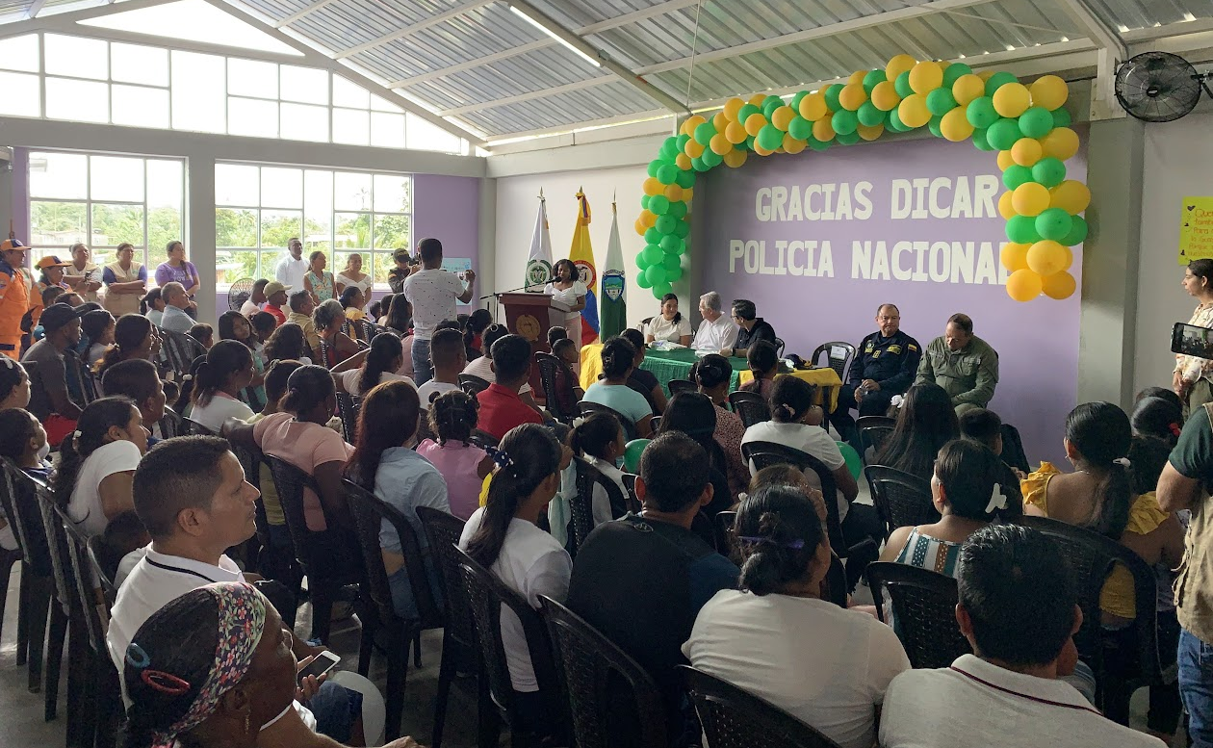

Improved Perception and Trust

in Rural Police

Baseline and Exit Line Analysis: Community perception regarding DICAR, support for small producer organizations, social capital and trust

Detailed results of baseline (BL) and exit line (EL), along with measurements of productive variables associated with the benefiting productive organizations, are presented in Annex 2 of this report. The total sample of surveyed households decreased by 14% between BL (615 households) and EL (530 households), maintaining a similar distribution across agricultural beneficiaries (55-56%), infrastructure beneficiaries (13-14%), and non-beneficiaries (31%). This reduction in the sample size is common and expected during data collection due to factors like changes in residency or contact information. To address this, a sufficiently large baseline sample was established to ensure the subsequent collections remained significant despite reductions.

Baseline data was collected from April to July 2022 and processed in the second half of that year. Intermediate data collection occurred between May and September 2023 and processed in the first quarter of 2024. Exit line data was primarily collected in November 2023, with additional cases in April 2024 due to works dynamics. The latter were processed in the second quarter of 2024. Some key conclusions and recommendations of the report are the following:

- Significant progress was made in strengthening productive capacities and improving perceptions and trust toward DICAR and PONAL, aligning with the project’s objectives. Perception data, encompassing over 26 indicators, can serve as a crucial resource for decision-making by DICAR and other stakeholders.

- Notable increases were observed in production, productivity, and income from commercialization in supported productive lines (cacao, plantain, fish farming, and beekeeping). Strengthening strategies, such as technical assistance and investment in infrastructure and equipment, effectively enhanced the productive capacity of the beneficiary organizations.

- The Social Capital and Trust Index developed for the project enables the analysis of dynamics among territorial actors, showing very positive trends in the intervention territories that strengthen social fabric. Trust grew across the three analyzed actors (Community, Institutions, and DICAR) between baseline and exit line. However, some differences are recognized among them, showing a greater trust of people towards the community, followed by institutions (government and church). However, in relation to the growth of these scores, DICAR exhibited the most significant change in terms of distribution and average value, with a 15-point increase in average trust scores. This demonstrates that DICAR experienced the greatest positive shift in trust perception among surveyed participants.

- In general, there was an increase in the trust index towards DICAR (from 31.5 to 46.7 points out of 100), largely due to statistically significant improvements in El Bagre, Montelíbano, Tierralta, Puerto Libertador, and Caucasia. The dimensions with the most significant increases suggest that the project positively impacted the perception that DICAR acts in good faith, communicates transparently, and is willing to collaborate with the community.

- This favorable change was observed among both direct and indirect beneficiaries of the project.

- In municipalities where DICAR had greater interaction and participation in community activities, more notable trust improvements were recorded.

- The perception of and trust in DICAR and PONAL significantly improved in key dimensions such as recognition, overall rating, and contribution to territorial development. Despite the progress, challenges remain in some municipalities due to contextual factors such as the presence of armed actors and complex security situations.

- To strengthen future strategies, several recommended actions were identified: enhancing DICAR's engagement and participation within communities through regular spaces for dialogue and collaboration.

- It is deemed valuable to first validate the level of feasible engagement with communities via participatory diagnostics and meetings with community leaders and strategically select intervention areas, prioritizing those with active DICAR presence and relatively stable security conditions.

- Ensuring the continuity and training of DICAR personnel is also recommended, promoting stability and enhancing interpersonal and project management skills to increase interaction opportunities in the territory.

- Adapting interventions to local contexts by conducting detailed prior analyses and establishing a long-term monitoring and evaluation system to ensure sustainability and timely adjustments in intervention strategies is also encouraged.

The following graphs highlight some of the favorable trends identified in the analysis. The detailed presentation of the full report can be found in Annex 3.

Graphs 1 and 2: DICAR Perception and Contribution to Security
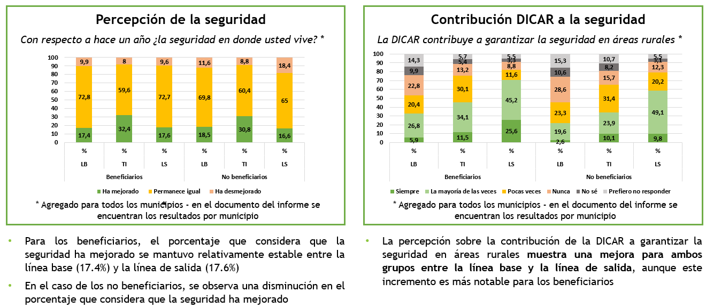

Graphs 3, 4, and 5: DICAR Contributions in Rural Environments and Coexistence
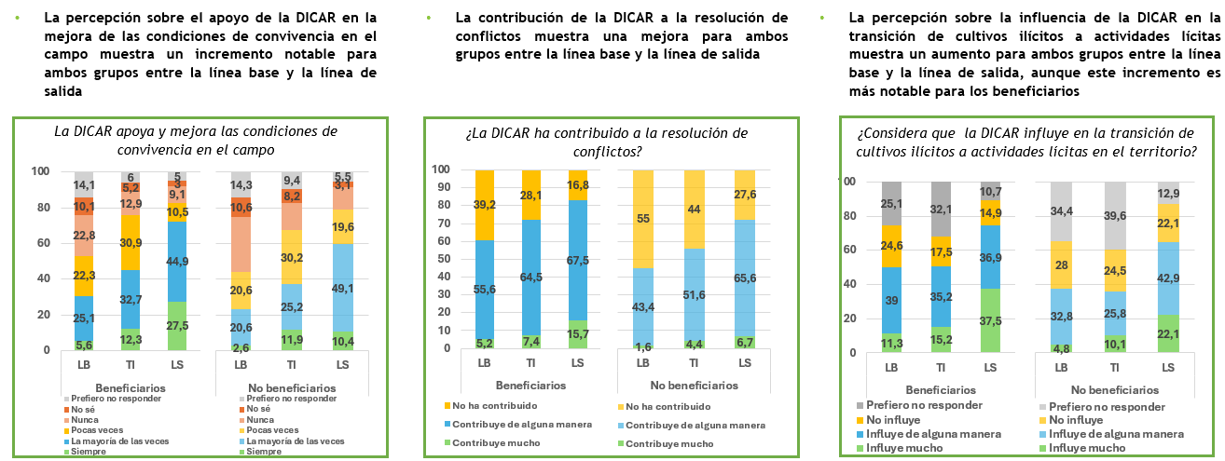

Graph 6: Variation in Social Capital and Trust by Stakeholders
Community | Institutions | DICAR
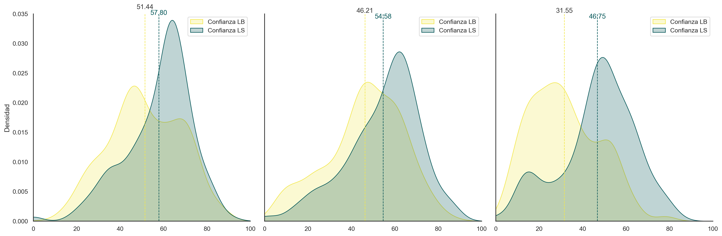

Graph 7: DICAR Trust Variation, Comparison between Beneficiaries and Non-Beneficiaries
Beneficiaries | Non-Beneficiaries
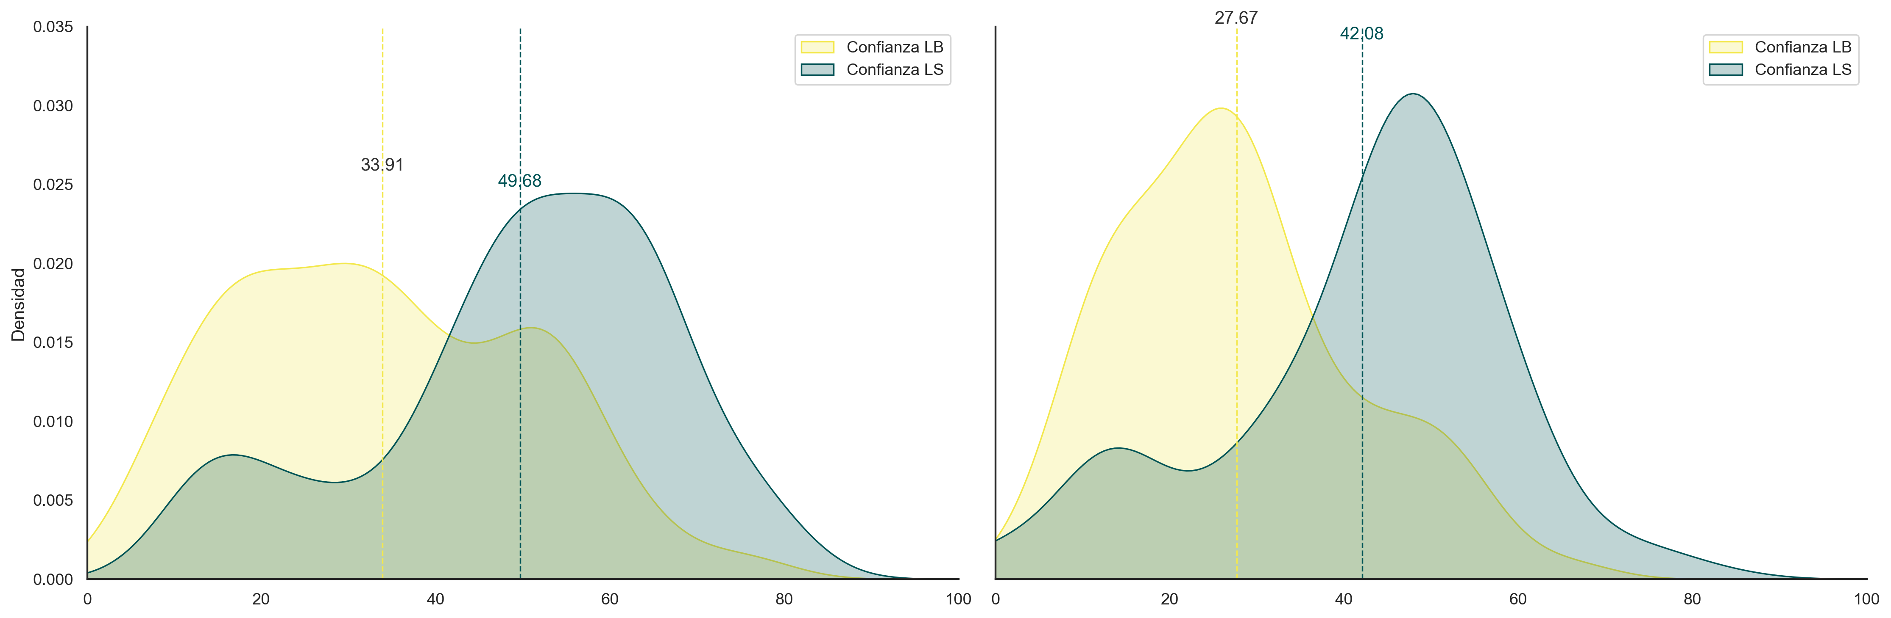
Table 4. Dimensions of the DICAR Trust and Social Capital Index for All Municipalities

ALL MUNICIPALITIES | Total |  |  |  |  | Beneficiaries |  |  |  |  | Non-Beneficiaries
ALL MUNICIPALITIES | BL | TI | EL | BL-EL | Foll. | BL | TI | ES | BL-EL | Sig. | BL | TI | EL | BL-EL | Foll.
Number of Surveys | 615 | 508 | 530 | -85 |  | 426 | 349 | 363 | -63 |  | 189 | 159 | 167 | -22
DICAR Trust Index | 31.5 | 37.7 | 46.7 | 15.2 | Foll. 5% | 33.4 | 39.1 | 49.1 | 15.7 | Foll. 5% | 27.3 | 34.8 | 41.6 | 14.3 | Foll. 5%
Honesty | 32.2 | 42.3 | 52.0 | 19.8 | Foll. 5% | 35.2 | 43.2 | 54.0 | 18.8 | Foll. 5% | 25.6 | 40.3 | 47.6 | 22.1 | Foll. 5%
Belonging | 51.6 | 51.9 | 67.7 | 16.1 | Foll. 5% | 53.0 | 52.1 | 69.4 | 16.3 | Foll. 5% | 48.5 | 51.3 | 64.1 | 15.6 | Foll. 5%
Cooperation | 30.7 | 37.4 | 48.9 | 18.2 | Foll. 5% | 31.8 | 40.0 | 52.5 | 20.7 | Foll. 5% | 28.1 | 31.8 | 40.9 | 12.8 | Foll. 5%
Respectful Treatment | 41.2 | 49.1 | 55.0 | 13.8 | Foll. 5% | 42.8 | 50.6 | 57.6 | 14.8 | Foll. 5% | 37.7 | 45.7 | 49.3 | 11.6 | Foll. 5%
Good Intentions | 30.5 | 44.4 | 57.6 | 27.0 | Foll. 5% | 32.6 | 45.8 | 60.6 | 28.0 | Foll. 5% | 25.8 | 41.5 | 50.9 | 25.0 | Foll. 5%
Relationship Building | 33.0 | 35.8 | 45.2 | 12.2 | Foll. 5% | 36.3 | 37.8 | 47.9 | 11.6 | Foll. 5% | 25.4 | 31.3 | 39.3 | 13.9 | Foll. 5%
DICAR Performance | 28.9 | 32.7 | 40.7 | 11.7 | Foll. 5% | 31.4 | 35.7 | 44.6 | 13.2 | Foll. 5% | 23.3 | 26.1 | 32.0 | 8.7 | Foll. 5%

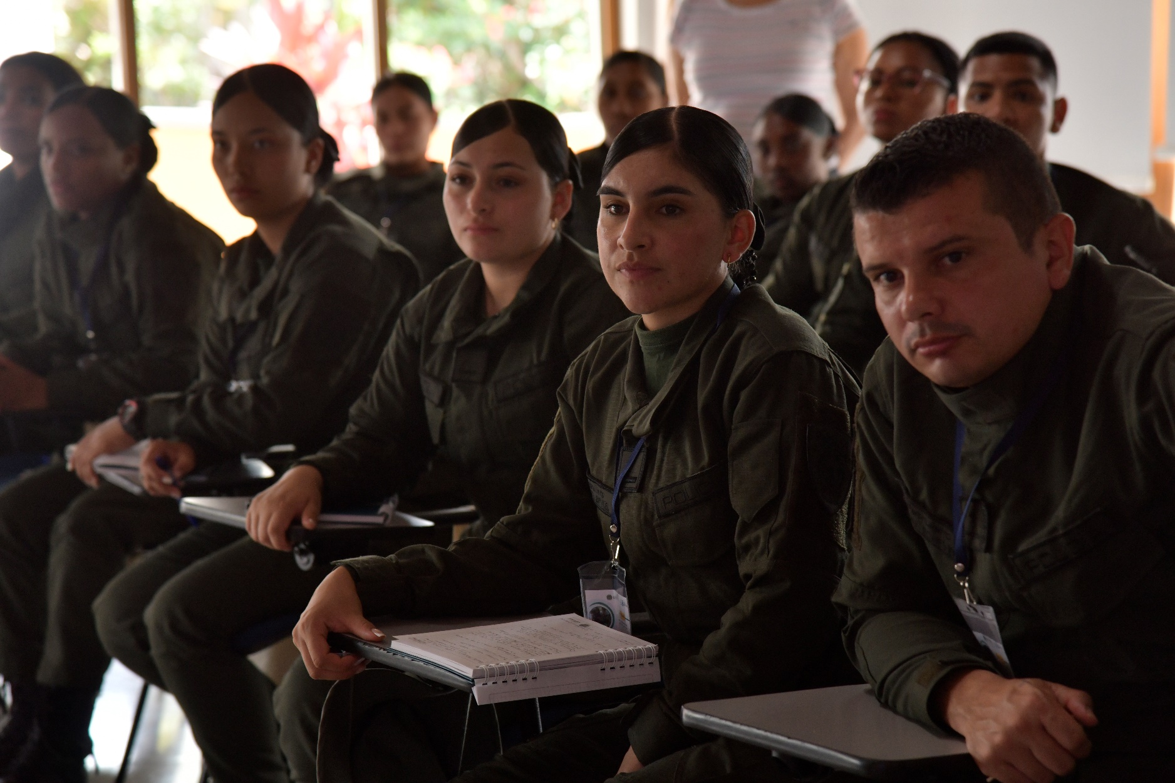

Lessons Learned

Lessons Learned

Annex 4 outlines the lessons learned and best practices identified for the second implementation phase, categorized by component. Below are some of the most relevant points:

The successful implementation of community projects involving the Female Rural Operations Squad (EFEOR) requires meticulous planning and effective inter-institutional coordination. It is essential to consider EFEOR’s capabilities and commitments while engaging all relevant stakeholders to ensure their active and sustainable participation.

- Training in soft skills for the National Police is critical to improving interaction with communities. However, effective training demands considerable time commitment. The project faced challenges in securing police availability for more than two or three days, highlighting the need for adequate time and resource planning to ensure full participation and true knowledge acquisition.

- While some officers demonstrated commitment and diligence in community engagement activities, these tasks often fall outside their official duties. For greater impact and project alignment, these activities should be formally integrated into their work plans by police headquarters and stations. This ensures that the commitment and effort of police officers in community management is recognized and sustainable in the long term.

- Collaboration between the police and farmers in identifying commercial allies is critical for ensuring the sale of crops produced through the project. Although this is outside the police’s traditional mission, such involvement fosters rural development and strengthens relationships with the population.

- Strengthening efforts such as technical assistance and investment in infrastructure and equipment proved effective in enhancing the productive capacity of beneficiary organizations.

- Scheduled follow-ups to projects and farmer organizations are essential for monitoring progress and ensuring effective implementation. However, it is important to consider the security restrictions that may impact the participation of external entities, such as INL. Planning ahead and developing alternative strategies can help mitigate these challenges and ensure continuity in follow-up activities.

- To ensure the appropriation, maintenance, and proper use of the infrastructure delivered to the community, local police must establish partnerships and maintain consistent community engagement through activities that mobilize and involve the community. It is essential for the police to strengthen their ties and relationships with local authorities and to map the available services or institutional offerings that can support the development of programs or activities, bringing vitality and dynamism to the infrastructure.

Financial Closing Report
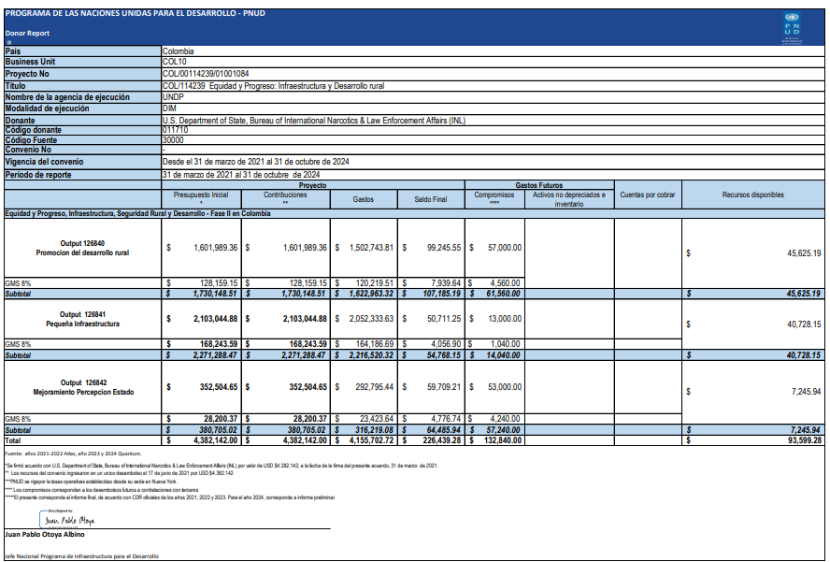

Annexes

- Annex 1. Territorial Productive Profiles
- Annex 2. Baseline and Exit Line Analysis: Community Perception regarding DICAR, Support for Small Producer Organizations, Social Capital and Trust
- Annex 3. Presentation of the Baseline and Exit Line Results: Community Perception
- Annex 4. Report on the Component for Strengthening Farmer Organizations
- Annex 5. Lessons Learned from Project Closure

The Organizational and Community Strengthening Pathway is a training cycle involving the National Police during the construction of community projects in the territories targeted by the project.
Please refer to the annexes accompanying this report.

